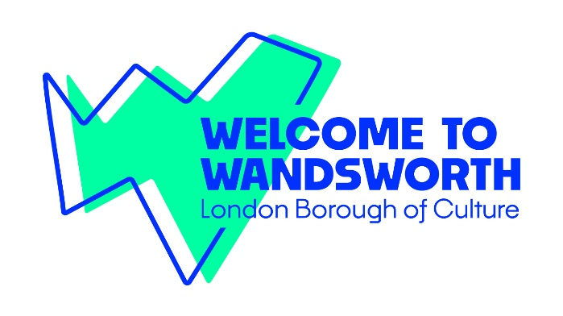Participatory R&D Grants

Liberty Festival 2025

Application Form

These grants are to support disability organisations in experimenting and sharing new ways of working, collaborating and advocating for the sector through artistic collaboration.

Six Participatory R&D Grants of £1,500 each offer opportunities for disabled artists and community groups to explore themes that are close to their hearts in new and innovative ways, with a view to develop socially engaged work for Liberty Festival 2025.

**This R&D work could be led either by disabled artists to work with community groups of their choosing, or by disability organisations to work with disabled artist(s) of their choice.** This direct collaboration on advocacy and development of creative ideas will allow disabled artists to benefit from the trust and connection that community groups have already developed locally and ensure access to professional artists to those groups.

If you would like to apply but don’t know who to collaborate with, we would be delighted to signpost and broker connections between artists, organisations and community groups. Please contact us on [culture@wandsworth.gov.uk](mailto:culture@wandsworth.gov.uk) for support with this.

Please complete the below form to give us details about your proposal. You can also send us your proposal as a captioned video document.

This information is available in large print, BSL and audio formats. If you require this information in another format or access support to apply, please email [culture@wandsworth.gov.uk](mailto:culture@wandsworth.gov.uk).

Please send your R&D proposal to [culture@wandsworth.gov.uk](mailto:culture@wandsworth.gov.uk) by **midday on Wednesday 8th January**.

Where the group and artists have both been identified please complete both sections of Part 1. If the applicant has not yet identified a Wandsworth-based Community Group or the Artistic Partner, please only complete the relevant section within Part 1.

**PART 1**

### About the Wandsworth-based Community Group

|  |  |  |
| --- | --- | --- |
| Organisation: |  | |
| Website: |  | |
| Address: |  | |
| Contact name: |  | |
| Telephone: |  | |
| Email: |  | |
| Which user group(s) will be part of this project? |  | |
| Do the user group(s) participants identify as (delete any that do not apply) | Physically disabled  D/deaf  Learning disabled  Neurodivergent  Affected by a long-term health condition  Other disabled identity (please state): | |
| Has the community group confirmed their interest in this collaboration? | YES | NO |

**AND/OR**

### About the artistic partner

|  |  |  |
| --- | --- | --- |
| Artist/Organisation / Collective’s name: |  | |
| Address: |  | |
| Telephone: |  | |
| Email: |  | |
| Website: |  | |
| Tell us about the artist’s creative practice |  | |
| Does the artist identify as (circle all that apply) | Physically disabled  D/deaf  Learning disabled  Neurodivergent  Affected by a long-term health condition  Other disabled identity (please state): | |
| Has the artist confirmed their interest in this collaboration? | YES | NO |

**Part 2**

### About your R&D project

**1. Tell us what you would like to do (500 words or 4-min video max).**

|  |
| --- |
|  |

**2. Tell us what you hope to achieve through this Participatory R&D (300 words or 2-min video max).**

|  |
| --- |
|  |

**3. How many professional artists will your R&D project employ?**

|  |  |
| --- | --- |
|  | Learning disabled artists |
|  | Physically disabled artists |
|  | D/deaf artists |
|  | Neurodivergent artists |
|  | Artists affected by a long-term health condition |

**4. How many participants will your R&D project work with?**

|  |  |
| --- | --- |
|  | Under 16 |
|  | 16-25 |
|  | Adults aged 25-70 |
|  | Over 70s |

Budget* (this can be verbally delivered via the video)

Please bear in mind the following guidelines:

* You can apply for **up to £1,500** from this fund.
* Your organisation, with the support of your chosen artistic partner, can decide how the funds will be distributed. This includes what portion are artist fees and what portion is allocated to project running costs like translation, money transfer charges, equipment, administration, subscriptions, etc. Please outline in the table below **how the funds will be distributed**.
* **Access funding** is available separately both to support access to applications and/or access to support the project. In the budget, applicants will be asked to give figures for the access costs for the whole R&D proposal. This is to ensure that the fund can cover all costs and will not form part of the panel’s decision-making. Feel free to use Disability Arts Online’s [Access Rider open template](https://disabilityarts.online/magazine/opinion/access-rider-open-template/).
* **Match-funding**, although welcome, is not mandatory: funding from this award can cover 100% of the project costs, or part-fund them if other sources of funding are available.
* **In kind contributions** can be discounted or donated materials, venue hire, transport etc. and can also be the contribution of professional time, both artistic and administrative.
* **Be clear** about how you have arrived at the figures in your budget. For example, if you have put £70 as a venue hire, please explain the hourly, or daily rate e.g. 2 hours at £35 per hour = £70. All items must be clearly broken down and must evidence value for money.

If needed, please add more lines to both the expenditure and income tables.

|  |  |  |  |
| --- | --- | --- | --- |
| **Expenditure** | **Breakdown of Costs** | **£ cash** | **£ in-kind** |
|  |  |  |  |
|  |  |  |  |
|  |  |  |  |
|  |  |  |  |
| **Total Expenditure** |  |  |  |
| **Grand Total Expenditure** | Cash + in-kind income |  | |
|  |  |  |  |
| **Income** |  | **£ cash** | **£ in-kind** |
| Request from this R&D fund |  |  |  |
|  |  |  |  |
|  |  |  |  |
|  |  |  |  |
| **Total Income** |  |  |  |
| **Grand Total Income** | Cash + in-kind income  This figure should equal the Grand Total Expenditure |  | |

Declaration (if you are submitting a video, please include a verbal declaration of each of the below points)

I accept that the information provided in this application is, to the best of my knowledge, true and accurate.

If the application is submitted from an organisation, I confirm that the organisation named in this application has given me the authority to sign this application on their behalf.

I confirm that the activity in the application falls within the powers of the organisation’s constitution or memorandum and articles of association (the legal document setting out the rules governing the organisation).

I confirm that I or the organisation named in this application will have public liability in place for the duration of the proposed activity.

I understand that Wandsworth Arts and Culture Service may share my personal information (name, address, telephone number and email address) with other grant giving bodies to which I am applying for funds, but that my personal information will not be shared with any other third parties.

I confirm that I will complete an evaluation report and share all the relevant information with the Council within 2 months of the end of the funded activity.

|  |  |  |
| --- | --- | --- |
| Signature | Print name | Date |
|  |  |  |

*Typing your name here will be taken as a binding signature.*

If you are submitting a video, please end the video with your name and date.

Please return this form or your captioned video by **midday on Wednesday 8th January 2025** to: [**culture@wandsworth.gov.uk**](mailto:culture@wandsworth.gov.uk).

